VISAGO USER MANUAL

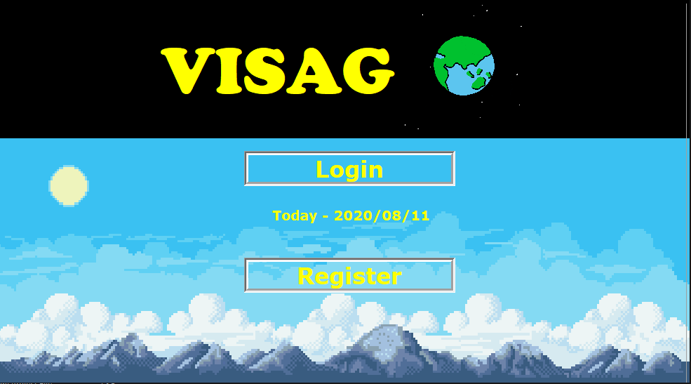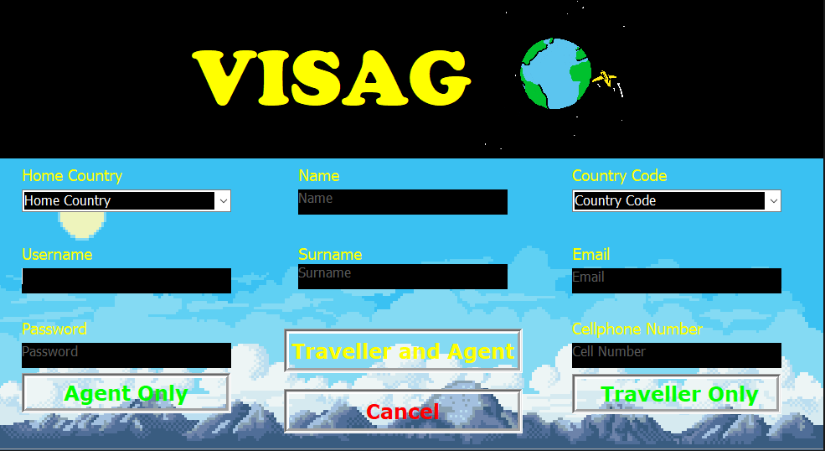**REGISTER AND LOGIN**

Figure B

Figure A

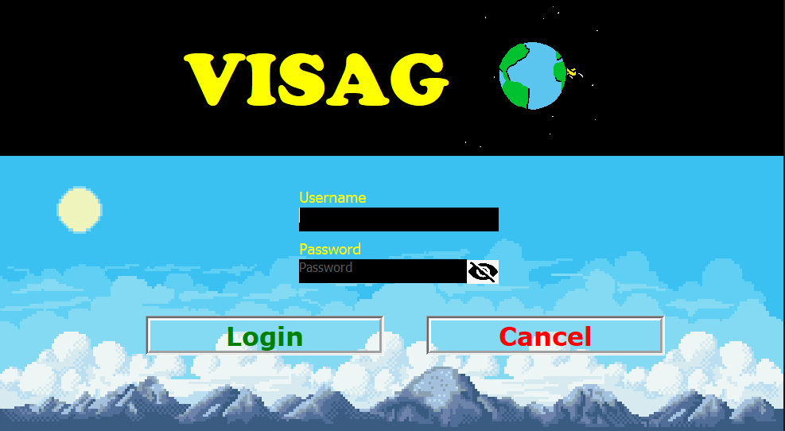

Figure C

Figure A:

* Button ‘Login’ - Takes you to Figure C
* Button ‘Register’ - Takes you to Figure B

Figure B

* Button ‘Agent Only’ – Registers you as an Agent only.
* Button ‘Traveller Only’ – Registers you as a Traveller only.
* Button ‘Traveller and Agent’ – Registers you as both a Traveller and an Agent.

Figure C

* Button ‘Login’ – Logs your user in as either an Agent or Traveller depending on what you select.
* Hide eye – Displays or Hides password.

Button ‘Cancel’

* Switches from Figure C to Figure A
* Switches from Figure B to Figure A

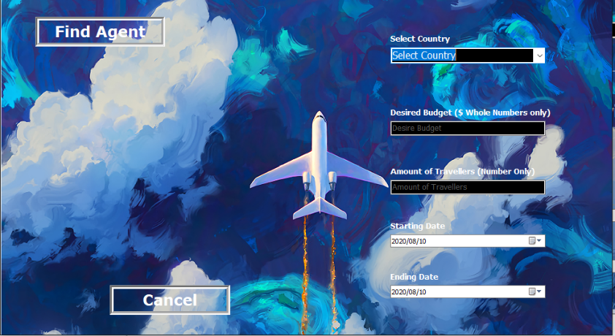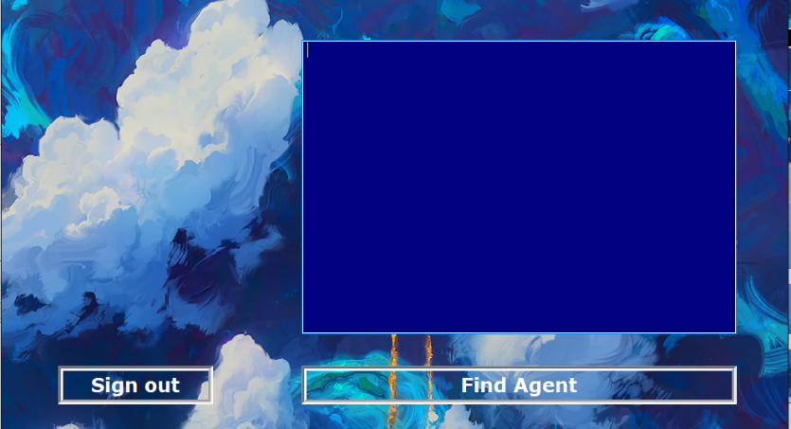**Traveller**

Figure D

Figure E

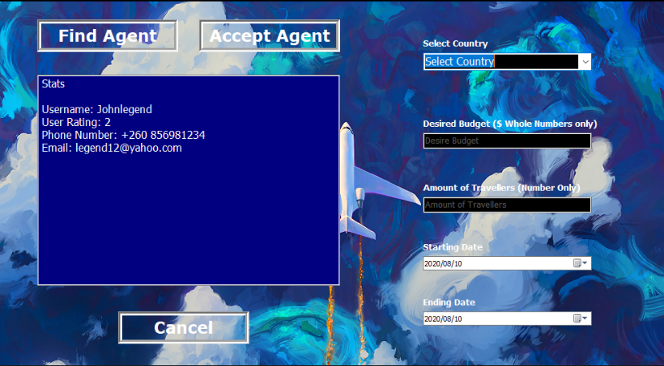

Figure F

Figure D

* Button ‘Sign Out’ – Closes Application.
* Button ‘Find Agent’ – Switches from Figure D to Figure E. Find an agent to help you plan your trip.

Figure E

* Button ‘Find Agent’ – Find an available agent to help you plan your trip.

Figure F

* Button ‘Accept Agent’ – Fill all Fields and then accept agent you are happy with. Note the application only goes through the agents once, so you might have to click Button ‘Cancel’ to start looking through the agents again.
* Switches from Figure F to Figure D

Button ‘Cancel’

* Switches from Figure F to Figure D
* Switches from Figure E to Figure D

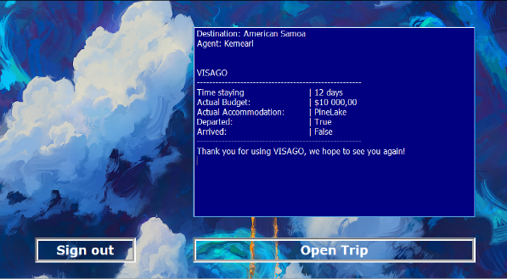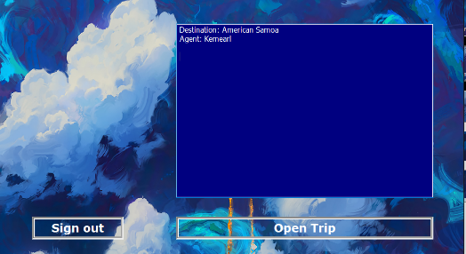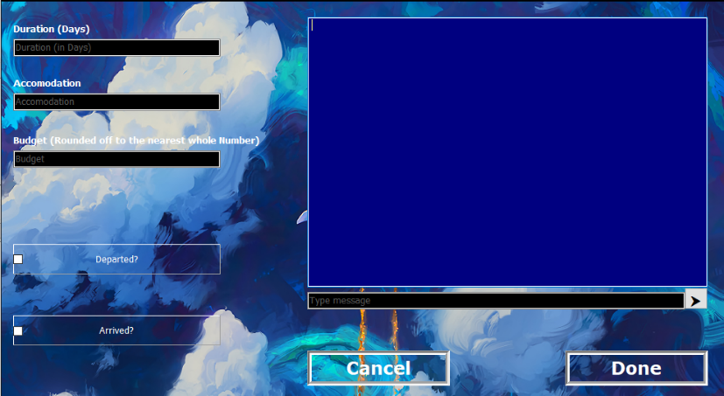

Figure I

Figure H

Figure G

Figure G

* Button ‘Sign out’ – Closes Application.
* Button ‘Open Trip’ – Switches from Figure G to Figure H. This will open a form where you will edit your trip details.

Figure H

* Button ‘Cancel’ – Switches from Figure H to Figure G
* Button ‘Done’ – After all Fields are filled in, you will be asked to rate your experience then the Figure H will be switched to Figure G

Figure I

* This will print your receipt after you have made changes to your Trip.

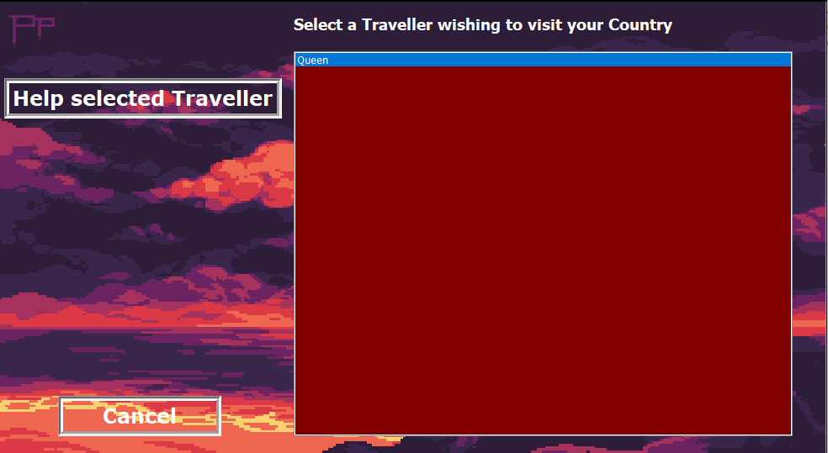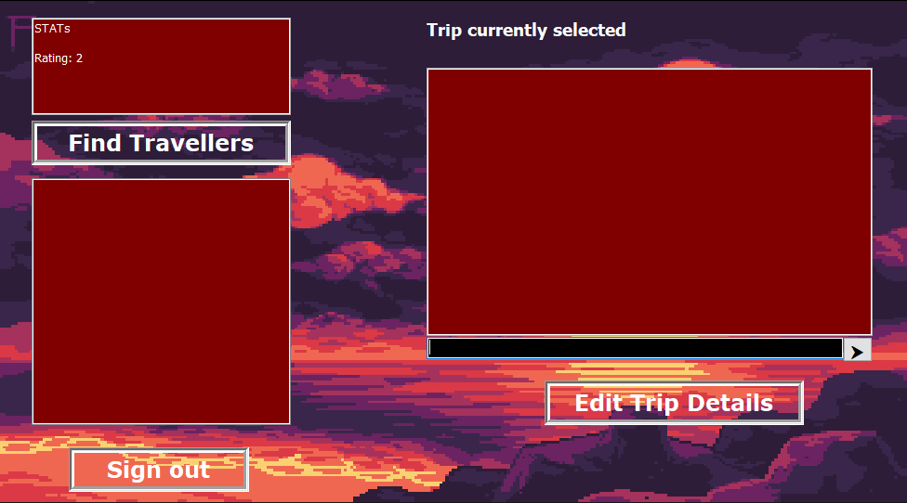**Agent**

Figure K

Figure J

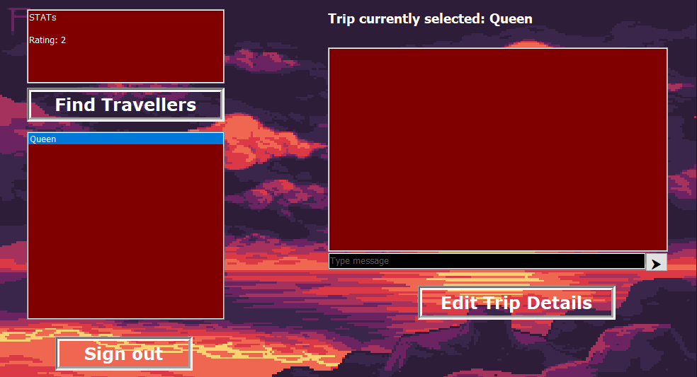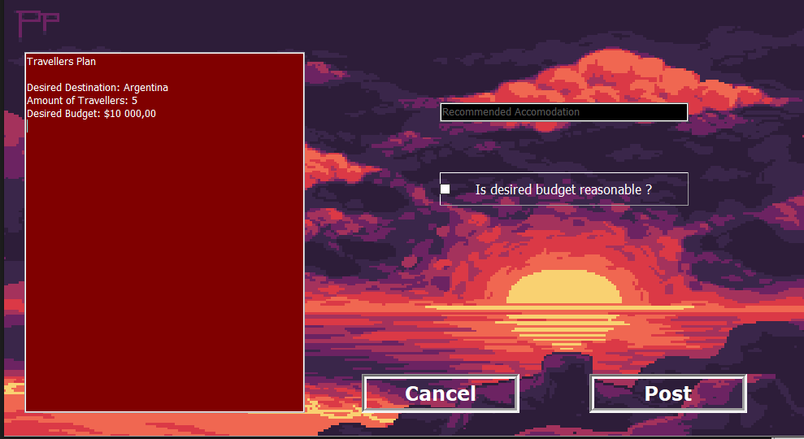

Figure M

Figure L

Agent Flow

* From Figure J select Button ‘Find Travellers’ which will lead to Figure K, here you will select a user and click Button ‘Help Selected Traveller’, this will take you to Figure L.
* From Figure L select a user in the box under the Button ‘Find Travellers’, “Queen is selected in this example” then proceed by clicking Button ‘Edit Trip Details’ this should take you to Figure M.
* Here the Agent (You) can update your recommended Accommodation and agree/disagree with the budget. If you want to make changes, click Button ‘Post’.

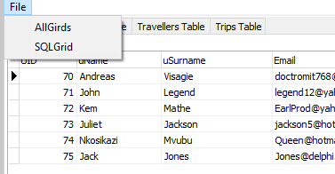**Server**

Figure O

Figure N

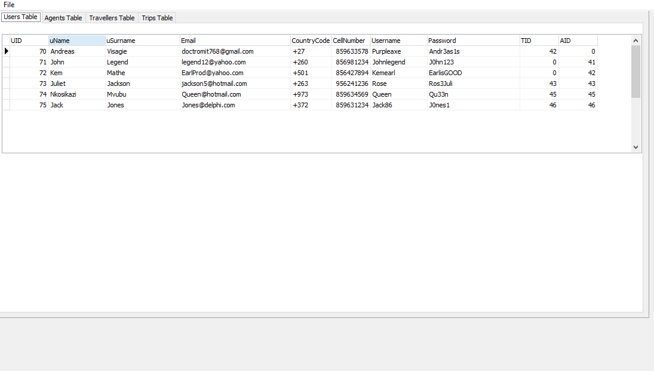

Figure P

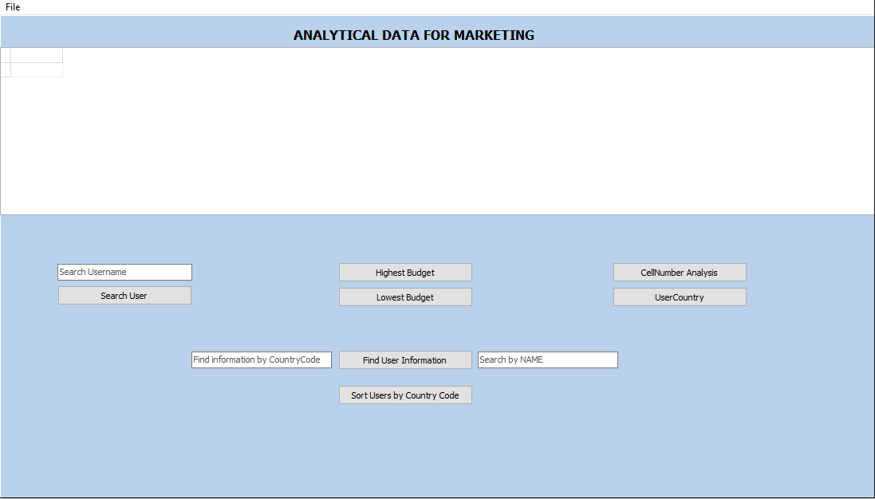

Figure N

* Displays all databases, uses tabs to put databases in different forms.

Figure O

* Selecting ‘AllGrids’ will take you to Figure N.
* Selecting ‘SQLGrid’ will take you to Figure P.

**ChatRoom Setup**

Figure Q

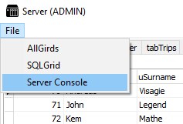

Figure Q

* Select Server Console for the dropdown menu in order to open the Server for VISAGO.

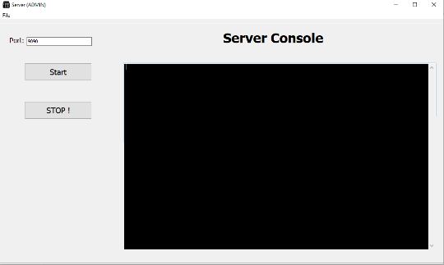figure R

Figure R

* This is the console that controls the server.

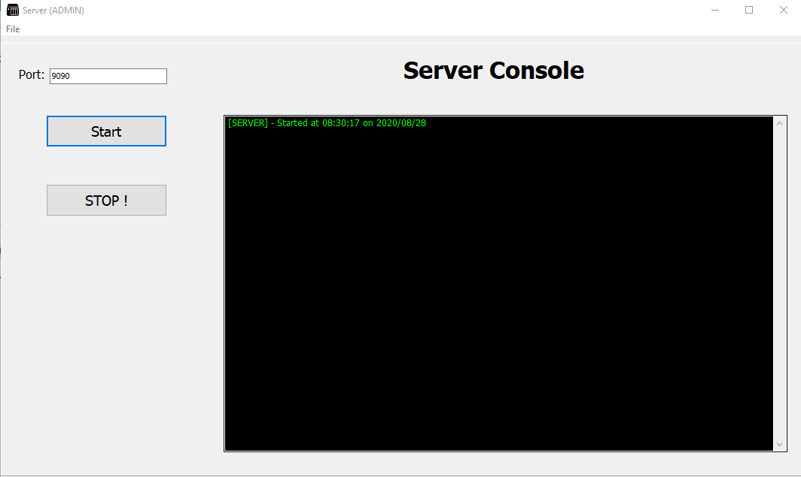Figure S

Figure S

* Button ‘Start‘- This starts the server which allows the users to communicate with one another.
* Button ‘Stop’ – This stops the server and disables all communications between clients.

**Client Communication Example**

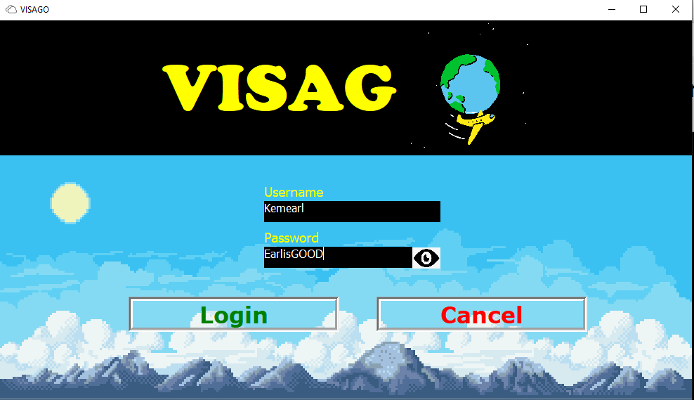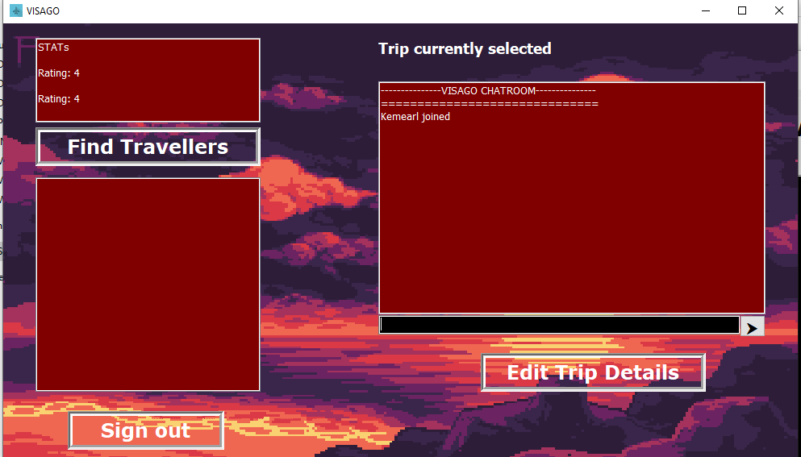

Client A

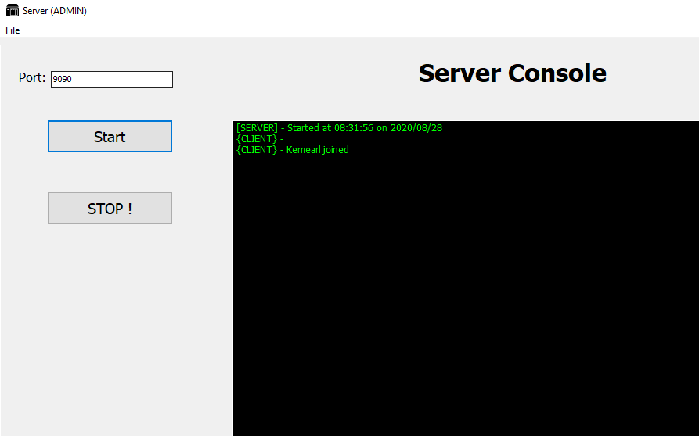

Server

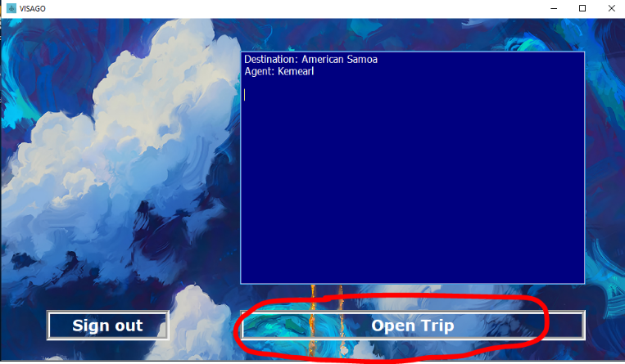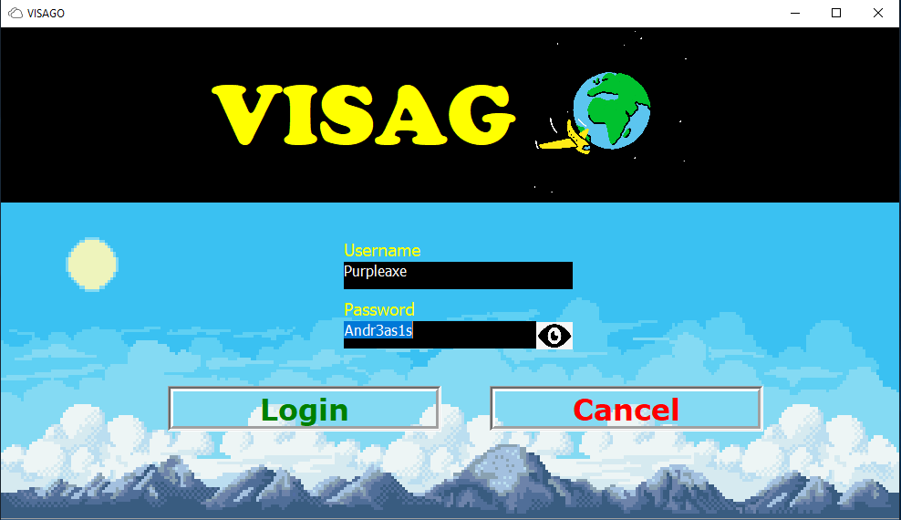

Client B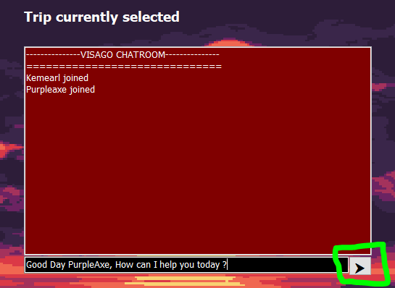

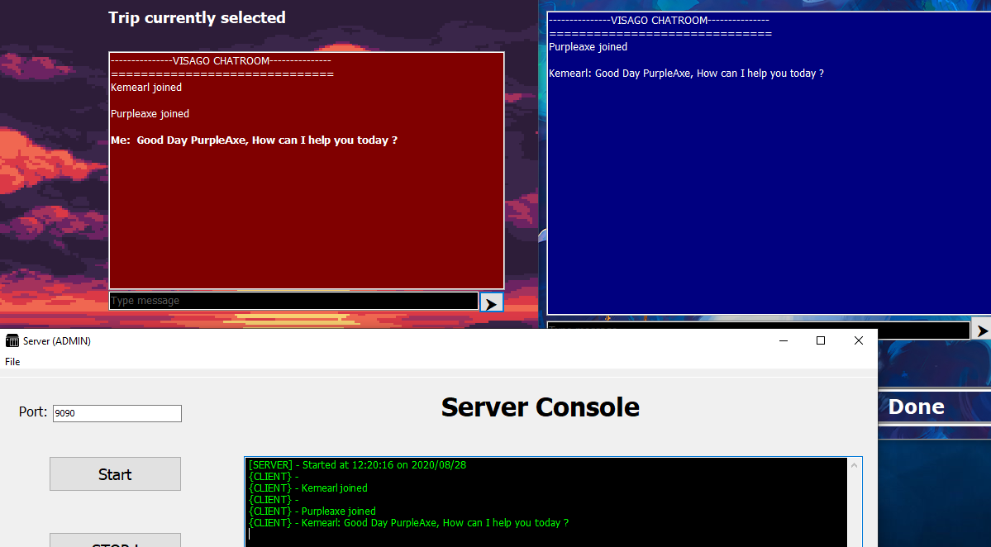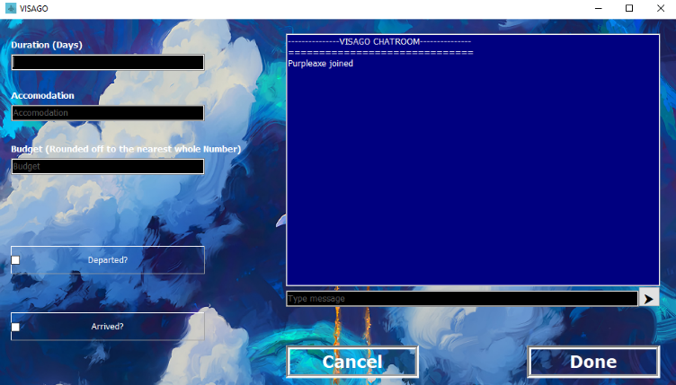

Clients A, B and Server

Client A